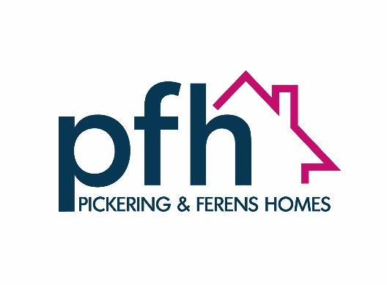

**PERSON SPECIFICATION**

**Customer SERVICES MANAGER**

|  |  |  |  |
| --- | --- | --- | --- |
| SECTION | CRITERIA | Competency Level * |  |
| **Education and Qualifications** | * A degree or NVQ Customer Services level 3 or 4 (or equivalent) | Certification/Application/Interview | |
|  |  |  | |
| **Experience, Knowledge and Understanding** | * Previous experience of service and team management in a customer service/call handling setting, including the use of customer relationship management systems. * Experience of monitoring and improving delivery of a first line customer service with the emphasis on effective enquiry resolution. * Experience of working with residents or delivering housing related services. * Experience of managing a centralised office service within an agile work environment. * Experience of budget management. * Knowledge of general office-based health and safety requirements. * Strong administration experience and IT skills. * Development and delivery of online service options | Certification/Application/Interview | |
|  |  |  | |
| **Working With People** | Influences and persuades peers and team members to work cooperatively and achieve common goals   * Builds a high calibre diverse team. * Coaches and develops their team to increase productivity and achieve greater performance levels. * Contributes to the development of a clear team identity, actively builds team spirit. * Operates with confidence in a group setting; project group; meetings and in a remote team. * Passionately champions excellence in customer relationship management | Interview | |
|  |  |  | |
| **Communicating & Influencing** | Communicates ideas and information in an effective and compelling manner that is clear, intelligible, convincing and timely, adapting own style to suit the situation.   * Makes presentations and speaks in group settings with skill and confidence. * Encourages team to engage in transparent and inclusive communication and to work collaboratively across departments. * Understands the complex viewpoints of others, recognises where compromise is necessary and brokers agreement to move forward * Communicates persuasively and confidently. * Presents a credible and positive image both internally and externally. | Interview | |
|  |  |  | |
| **Driving Positive Outcomes** | Pursues goals and objectives energetically, transmitting enthusiasm to others, overcoming obstacles to ensure we achieve the outcome we are looking for.   * Sets high performance standards for self and others. * Celebrates positive outcomes and praises effectively. * Approaches day to day work and objectives positively and energetically and maintains a positive outlook. * Learns from success and failure and actively seeks feedback from others to change and improve. | Interview | |
|  |  |  | |
| **Enthusiasm for Customer Service** | Makes the customer “live and central” in their thoughts and decisions, demonstrates enthusiastic excellent customer service to both internal and external customers.   * Clarifies the customers real needs and expectations without making assumptions. * Finds ways to exceed customer expectations. * Interacts with customers in an engaging and courteous manner. * Maintains an appropriate level of professionalism and regard for Adult Safeguarding at all times. * Co-develops and implements business plans with customer insight. * Measures customer satisfaction and develops KPI’s appropriate to their area of business. * Offers customers choice in customer service options | Interview | |